Motion as fundamental concept of human existence

¹ Technical University of Cluj Napoca
² E-mail:
Abstract. Motion is one of the key topics in physics. Everything in the universe moves. It might only be a small amount of movement and very very slow, but movement does happen. Don't forget that even if you appear to be standing still, the Earth is moving around the Sun, and the Sun is moving around our galaxy. The movement never stops. Motion is one part of what physicists call mechanics. Over the years, scientists have discovered several rules or laws that explain motion and the causes of changes in motion. There are also special laws when you reach the speed of light or when physicists look at very small things like atoms.

1.Overview
In this section we will get some information about general motion, and some important ideas about the types of motion and the laws of motion, also some general information about how motion is based on human living.

Figure 1. Motion in real lifetime

1.1.Laws of motion
In physics, motion in the universe is described through two sets of apparently contradictory laws of mechanics. Motions of all large scale and familiar objects in the universe (such as projectiles, planets, cells, and humans) are described by classical mechanics. Whereas the motion of very small atomic and sub-atomic objects is described by quantum mechanics. Motion can be illustrated like in Figure 1.
1.2.Classical mechanics
Classical mechanics is used for describing the motion of macroscopic objects, from projectiles to parts of machinery, as well as astronomical objects, such as spacecraft, planets, stars, and galaxies. It produces very accurate results within these domains, and is one of the oldest and largest subjects in science, engineering and technology. Classical mechanics is fundamentally based on Newton's Laws of Motion. These laws describe the relationship between the forces acting on a body and the motion of that body. They were first compiled by Sir Isaac Newton in his work Philosophiæ Naturalis Principia Mathematica, first published on July 5, 1687. His three laws are:
- In the absence of a net external force, a body either is at rest or moves with constant velocity.
- The net external force on a body is equal to the mass of that body times its acceleration; F = ma. Alternatively, force is proportional to the time derivative of momentum.
- Whenever a first body exerts a force F on a second body, the second body exerts a force −F on the first body. F and −F are equal in magnitude and opposite in direction.
Newton's three laws of motion, along with his law of universal gravitation, explain Kepler's laws of planetary motion, which were the first to accurately provide a mathematical model or understanding orbiting bodies in outer space. This explanation unified the motion of celestial bodies and motion of objects on earth.
Classical mechanics was later further enhanced by Albert Einstein's special relativity and general relativity. Special relativity explains the motion of objects with a high velocity, approaching the speed of light; general relativity is employed to handle gravitation motion at a deeper level.

1.3. Quantum mechanics

Quantum mechanics is a set of principles describing physical reality at the atomic level of matter (molecules and atoms) and the subatomic (electrons, protons, and even smaller particles). These descriptions include the simultaneous wave-like and particle-like behavior of both matter and radiation energy, this described in the wave–particle duality shown in Figure 2. In contrast to classical mechanics, where accurate measurements and predictions can be calculated about location and velocity, in the quantum mechanics of a subatomic particle, one can never specify its state, such as its simultaneous location and velocity, with complete certainty (this is called the Heisenberg uncertainty principle).In addition to describing the motion of atomic level phenomena, quantum mechanics is useful in understanding some large scale phenomenon such as superfluidity, superconductivity, and biological systems, including the function of smell receptors and the structures of proteins.
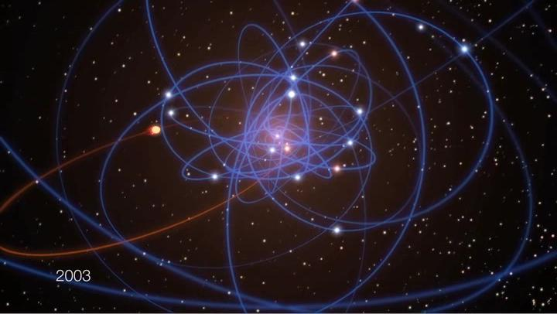
Figure 2. Atomic level

1.4. Kinematics
Kinematics applies geometry to the analysis of movement, or motion, of a mechanical system.The rotation and sliding movement central a mechanical system is modeled mathematically as Euclidean, or rigid, transformations. The set of rigid transformations in three dimensional space forms a Lie group, denoted as SE(3).

2. List of "imperceptible" human motions
Humans, like all things in the universe are in constant motion, however, aside from obvious movements of the various external body parts and locomotion, humans are in motion in a variety of ways which are more difficult to perceive. Many of these "imperceptible motions" are only perceivable with the help of special tools and careful observation. The larger scales of "imperceptible motions" are difficult for humans to perceive for two reasons: 1) Newton's laws of motion (particularly Inertia) which prevent humans from feeling motions of a mass to which they are connected, and 2) the lack of an obvious frame of reference which would allow individuals to easily see that they are moving. The smaller scales of these motions are too small for humans to sense.

2.1. Universe

Spacetime (the fabric of the universe) is actually expanding. Essentially, everything in the universe is stretching like a rubber band. This motion is the most obscure as it is not physical motion as such, but rather a change in the very nature of the universe. The primary source of verification of this expansion was provided by Edwin Hubble who demonstrated that all galaxies and distant astronomical objects were moving away from us ("Hubble's law") as predicted by a universal expansion.

2.2. Galaxy

The Milky Way Galaxy, is hurtling through space at an incredible speed. It is powered by the force left over from the Big Bang. Many astronomers believe the Milky Way is moving at approximately

600 km/s relative to the observed locations of other nearby galaxies shown in Figure 3. Another reference frame is provided by the Cosmic microwave background. This frame of reference indicates that The Milky Way is moving at around 552 km/s.

Figure 3. Galaxy

2.3. Solar System

The Milky Way is rotating around its dense galactic center, thus the solar system is moving in a circle within the galaxy's gravity. Away from the central bulge or outer rim, the typical stellar velocity is between 210 and 240 km/s (about half-million mi/h).

2.4. Earth
The Earth is rotating or spinning around its axis, this is evidenced by day and night, at the equator the earth has an eastward velocity of 0.4651 km/s (1040 mi/h).
The Earth is orbiting around the Sun in an orbital revolution. A complete orbit around the sun takes one year or about 365 days; it averages a speed of about 30 km/s (67,000 mi/h).

2.4. Internal body
The human heart is constantly contracting to move blood throughout the body. Through larger veins and arteries in the body blood has been found to travel at approximately 0.33 m/s.[17] Though considerable variation exists, and peak flows in the venae cavae have been found between 0.1 m/s and 0.45 m/s.
The smooth muscles of hollow internal organs are moving. The most familiar would be peristalsis which is where digested food is forced throughout the digestive tract. Though different foods travel through the body at rates, an average speed through the human small intestine is 2.16 m/h (0.036 m/s).
Typically some sound is audible at any given moment, when the vibration of these sound waves reaches the ear drum it moves in response and allows the sense of hearing.
The human lymphatic system is constantly moving excess fluids, lipids, and immune system related products around the body. The lymph fluid has been found to move through a lymph capillary of the skin at approximately 0.0000097 m/s.

2.5. Particles
According to the laws of thermodynamics all particles of matter are in constant random motion as long as the temperature is above absolute zero. Thus the molecules and atoms which make up the human body are vibrating, colliding, and moving. This motion can be detected as temperature; higher temperatures, which represent greater kinetic energy in the particles, feel warm to humans whom sense the thermal energy transferring from the object being touched to their nerves. Similarly, when lower temperature objects are touched, the senses perceive the transfer of heat away from the body as feeling cold.

3.Summary
As a conclusion of the laws of intertia which can describe the law of motion and motion in generally a body at rest continues to stay at rest and a body in uniform motion tends to stay in uniform motion along a straight line unless it is acted upon an external force.
4.Acknowledgments
This paper was inspired from the summary Wikipedia: Motion, Physics4kids: Motion introduction.
7.References
[1] Mary Plummer (2005). Getting started with motion APPLE.
[2] Tony Hills In Motion: The experience of travel 339 pp. Alfred A. Knopf.

